Rates of Reaction – part 1
Learning questions
- How do we know a reaction has taken place?
- What is needed for a reaction to take place?
- How can we speed up or slow down a reaction?

What might you see when a chemical reaction happens?

Task 1

Demo 1

Task 2
- Potassium Iodide + Lead nitrate Potassium nitrate + Lead iodide

KI_{(aq)} + Pb(NO₃)_{2(aq)}
Describe what you observed. Did a chemical reaction take place? How do you know?

- Hydrochloric acid + Calcium carbonate Calcium chloride + H₂O + CO₂
HCl_{(aq)} + CaCO_{3(s)}
Has a chemical reaction taken place? Explain your answer.

Collision theory

A

BA

Task 3
Describe what the diagrams A and B are showing (white = Hydrogen and red = Oxygen)
A

B

Demo 2

Bond breaking and making
There are 2 molecules of hydrogen and 1 molecule of oxygen in the reaction above.
Task 4
How can we make 2 molecules of water? Describe what had to be done.

For a chemical reaction to occur particles must………
Collide with enough energy (activation energy) in order to break bonds and react.

What you need to know

Measuring the rate of a reaction
(How fast or slow does a reaction occur?)
To measure how fast a reaction occurs there must be a change that can be measured. For example, a gas being produced, a colour change, a change in temperature of maybe a solid being precipitated.
Can you think of a chemical reaction where a change occurs? Think back to the first demonstration. Take time to think about what might happen in a chemical reaction and what might be used to measure how fast the reaction occurs.
The change must be measured against time, for example, for the reaction of CaCO₃ and HCl, we could measure the amount of CO₂ evolved every 10 seconds.

Task 5
Complete the table
(You can use your notes, a textbook or the internet)
One has been completed for you.
Reaction | Description | What could be measured against time?
Mg_{(s)} + 2HCl_{(aq)} MgCl_{2(aq)} + H_{2(g)} | The reaction produces hydrogen gas. The reaction produces energy (exothermic).  There is a temperature rise. | The volume of hydrogen gas  or  ---------------------------------------  ---------------------------------------  ---------------------------------------
Na₂S₂O_{3(aq)} + 2HCl_{(aq)}  2NaCl_{(aq)} + H₂O_{(l)} + SO_{2(g)} + S_{(s)} | Sodium thiosulfate reacts with hydrochloric acid to produce a precipitate of sulfur. | The time it takes for the reaction mixture to become opaque (e.g., a disappearing cross).
CaCO_{3(s)}+ HCl_{(aq)}  CaCl_{2(aq)} + CO_{2(g)} + H₂O_{(l)} | The reaction produces---------------gas. | -------------------------------  -------------------------------  -------------------------------
Na₂S₂O_{3(aq)} is a solution of sodium thiosulfate

Collision theory and the rate of reaction
A reaction only occurs when molecules collide with enough energy to break some initial bonds.
So, how can we change the reaction conditions to speed up a reaction?
Can you remember what factors affect the rate of a reaction? Write them in the box below.
Task 6
1.
2.
3.
4.

Demo 3

Task 7
Before you begin this task you may like to attempt the tasks in the additional information section.
Watch the demonstration carefully and then fill in the table.
One has been completed for you.
Variable is increased | State what happens to the rate of reaction and explain why this happens
Concentration

Surface area
Temperature | The Rate of reaction will increase.  When temperature increases the particles have more energy on average. With greater energy particles will move faster. The faster they move the more collisions there will be. Also, because the particles are moving faster they will collide with greater energy. This in turn means that there will be more collisions with enough energy to break bonds and so allow particles to react with each other.

The way a catalyst works will be explored in Rates of reaction – part 2.

Additional sheets
Looking at concentration

Key
Solvent (water)
Solute

Circle the solution that is most concentrated?
Box the solution that is least concentrated?
Are there any solutions that have the same concentration? Draw a triangle around these.

Now image that we increase the concentration of reactants. Because there are more reactant particles there will be more collisions and so the reaction should speed up if the collisions have enough energy!

Looking at surface area
Imagine the shape below is a lump of calcium carbonate. For ease imagine also that it is 2 dimensional (it is 3D really). There are 4 lines of attack that molecules of hydrochloric acid can take with the CaCO₃. The arrows show these (the top and bottom have been ignored).

v

There are 4 surfaces that can be attacked

Split the lump into two – increase the surface area

There are an additional 2 surfaces that can be attached (red arrows), which means more HCl can reach the CaCO₃. We can imagine this as the HCl not needing to cue up to attack and react with the CaCO_{3.} This means the reactions can happen faster!

Looking at temperature
When we want the temperature of something to increase, we supply more energy. This means that if the temperature increases there must be an increase in energy.
The more energy that particles have the faster they will move. If they move faster, they will collide with each other more often and the collision will have greater energy!

A

The molecules are moving fast in A. They have lots of energy, enough to break bonds.
B

These molecules in B are not moving as fast as they are in A. They have less energy.
Which reaction is likely to be the fastest, A or B? Explain your answer.
If the molecules in B did not react, what would your explanation be?

Test your understanding
Q1
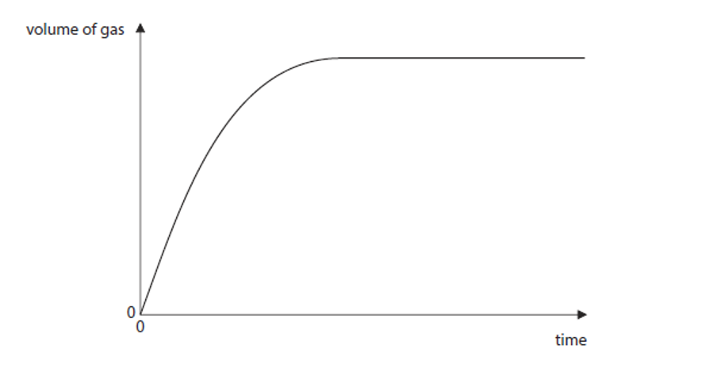

For the graph above describe its shape. Explain why the curve flattens.

Q2
True or False?
- The rate of reaction will increase as the temperature decreases
- A higher concentration will lead to faster reactions
- A higher surface area increases the rate of a reaction
- Endothermic reactions produce heat

Q3
Chemical reactions involve bonds being broken and made and these involve changes in energy. Which box correctly shows the energy changes during a chemical reaction?
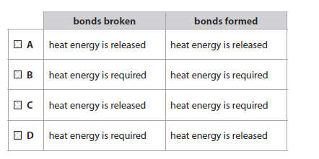
Q4
Which of the following pieces of evidence could suggest that a chemical reaction has taken place?
- The temperature increases
- Melting
- Colour change
- A gas is evolved (effervescence)

In Rates of Reaction – part 2 you will:
- understand how catalysts work
- draw and understand energy profiles for exothermic and endothermic reactions
- be able to plot and interpret Rate of Reaction data.

